IMF: Germany & UK enter recession in 2023
Sea-Intelligence – Press Release (Apr 19th, 2023)
www.Sea-Intelligence.com

The International Monetary Fund (IMF) recently published the April 2023 World Economic Outlook (WEO) report, and while these macroeconomic trends are not directly comparable to the container shipping industry, they are good indicators of the general health of the global economy, and can provide a guide to the direction that global trade is headed in.
IMF has projected a slowdown in trade growth, indicating that it will bottom-out in 2023, with a strong recovery in 2024. Figures for both 2023 and 2024, along with the respective changes from the previous report (published in January 2023) are shown in figure 1.
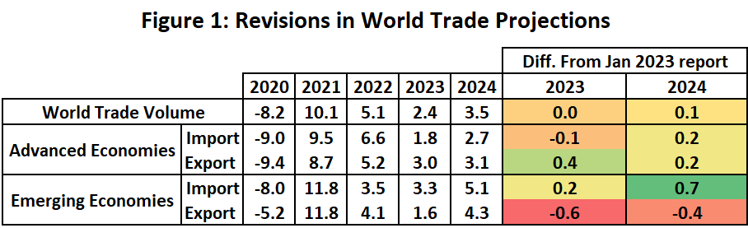
A rebound in 2024 is largely credited to the easing up of inflationary pressures on the market, unwinding supply chain disruptions following the pandemic, and receding dislocations to the energy and food markets following the Russia-Ukraine war.
A major concern however is that Germany and the UK are projected for a recession in 2023, with France perilously close to that line. While the UK was already projected to be in a recession in the January IMF update, Germany was projected for a marginal growth of 0.1% in 2023. The latter was marked down by -0.2 PP, while the former was marked up by 0.3 PP i.e., the UK was initially projected for a much stronger recession. France on the other hand is projected to see their economy grow by 0.7% in 2023, with their projection unchanged from the January 2023 report.
--- 000 --- END OF PRESS RELEASE --- 000 ---
All quotes can be attributed to: Alan Murphy, CEO, Sea-Intelligence.
For more information, please contact: ia@sea-intelligence.com, am@sea-intelligence.com

