2021: Significant tonnage tax advantage
Sea-Intelligence – Press Release (Mar 15th, 2022)
www.Sea-Intelligence.com

A range of countries offer shipping companies the opportunity to be taxed in accordance with tonnage tax regulations i.e. pay a fixed amount of tax per ton of tonnage deployed. This means that pre-tax income does not matter, and if you lose money, you still have to pay tax, but if you are suddenly extremely profitable, like with the carriers in 2021, you get a competitive edge versus the carriers that cannot avail themselves of such tonnage tax.
At the time of writing, Maersk, Hapag-Lloyd, CMA CGM, ZIM, and Matson published their full-year 2021 financials. For these carriers, the three large ones (Maersk, Hapag-Lloyd, and CMA CGM) fall under the tonnage tax rules, and have a tax rate of 0.7%-3.7%, whereas ZIM and Matson do not, and have a higher 18%-21% tax rate.
Looking at the three larger carriers against the average tax rate paid per TEU across these three carriers, we found that Maersk had a tax disadvantage of 10.3 USD/TEU, CMA CGM was mainly neutral, and Hapag-Lloyd had a tax advantage of USD 10.7 USD/TEU. This translated into a tax disadvantage of 269 million USD for Maersk, a 10 million USD disadvantage for CMA CGM, and a 127 million USD advantage for Hapag-Lloyd.
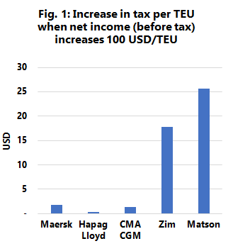
What is interesting however, is to see how the two carriers (who do not have a tonnage tax) compared to these larger carriers in terms of a tax relative competitive advantage/disadvantage. We found that ZIM paid a price of 953 million USD and Matson paid a price of 229 million USD in 2021, compared to a situation where their taxation per TEU had been the same as for the big three tonnage-taxed carriers. Another way of looking at it is shown in figure 1, where we have calculated how much additional tax in TEU is paid whenever the pre-tax income per TEU increases by 100 USD. The difference is very clear to see. For the big three carriers, every time the pre-tax profit increases by 100 USD/TEU, the taxation increases 0.30-1.80 USD/TEU. For ZIM and Matson, the increase in taxation as the pre-tax profit goes up by 100 USD/TEU is 18 and 26 USD/TEU, respectively.
--- 000 --- END OF PRESS RELEASE --- 000 ---
All quotes can be attributed to: Alan Murphy, CEO, Sea-Intelligence.
For more information, please contact: ia@sea-intelligence.com, am@sea-intelligence.com

