The US West Coast vessel queue will grow again
Sea-Intelligence – Press Release (Mar 1st, 2022)
www.Sea-Intelligence.com

The vessel queue outside of Los Angeles/Long Beach (LA/LB) recently dropped to 66 vessels from 100-105 vessels. While this does look like a light at the end of the tunnel, the data from Sea-Intelligence’s Trade Capacity Outlook (TCO) database shows otherwise.
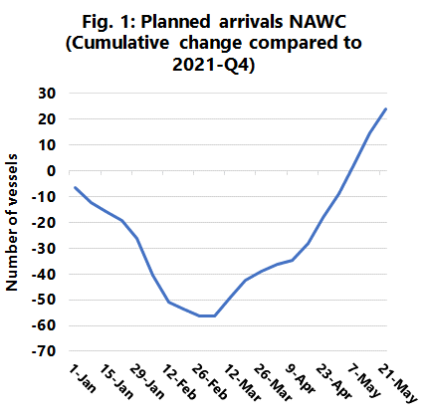
As a starting point, we modelled an average transit time of 2½ weeks from Asia, to get the expected number of vessel arrivals on US West Coast each week. If we take 2021-Q4 as a baseline, we can calculate the relative cumulative change in the number of vessel arrivals. As the TCO database is forward looking, we can do this out to May 9th, 2022, as in figure 1.
The maximum reduction is reached in the first week of March, with 60 fewer vessel arrivals compared to a situation where the 2021-Q4 flow had continued uninterrupted. It should be noted that in Q4, the queue outside LA/LB grew from approximately 80 vessels in October to 105 by the end of the year (a cumulative increase of 25 vessels). Because of the decline in Asian departures, we should expect 60 fewer vessel arrivals by the first week of March. If we assume this mainly impacts the LA/LB area, that would lead to a situation where the queue instead of growing to 120 vessels (based on the Q4 steady flow) would decline to 60 vessels, and we are presently seeing a queue of 66 vessels.
What is more worrying, is that the data would therefore also imply that if there are no other changes, then the queue will be 25 vessels larger than the baseline by the end of May 2022. The baseline, in keeping with the queue growth in 2021-Q4, would imply a queue of 145 vessels. Adding the additional 25 would bring the queue to 170 vessels.
This is extremely unlikely to happen – simply because there are not that many vessels to be had. What will happen instead, is that the sheer shortage of vessels will lead to many more blank sailings. What we saw during January appeared to be a kind of steady-state balance, between the desire to operate the required vessels and the need to blank sailings due to the vessels being unavailable. Hence, more realistically, we might simply be back to the 100-105 vessels in the queue, by the time we get to April.
--- 000 --- END OF PRESS RELEASE --- 000 ---
All quotes can be attributed to: Alan Murphy, CEO, Sea-Intelligence.
For more information, please contact: ia@sea-intelligence.com, am@sea-intelligence.com

