Congestion is getting worse (again….)
Sea-Intelligence – Press Release (Jan 11th, 2022)
www.Sea-Intelligence.com

In issue 546 of the Sunday Spotlight, we looked at the data from the November 2021 issue of the Global Liner Performance report to calculate how much vessel capacity was being effectively removed from the market due to vessels being tied up on seemingly interminable queues around the world. We also used the bi-weekly customer advisories from HMM to calculate a terminal congestion index.
Overall, 11.5% of the global capacity has been taken out of the market due to vessel delays in November 2021, a slight improvement from 12.3% in October 2021. However, judging by the data, it seems that there is no sign of imminent improvement. The normal state of affairs in the market is that 2% of global capacity is “trapped” in delays somewhere. It also clearly shows the sheer magnitude of the problem in 2021. Basically, 2021 was a year where demand grew 7% year-on-year (partly due to the downfall in early 2020) and at the same time capacity effectively was reduced by 11%.
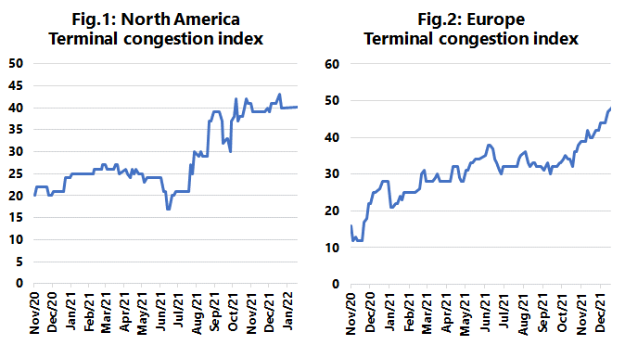
In terms of terminal congestion, figures 1 and 2 show the results of our terminal congestion index (quantifying HMM’s customer advisories) for North America and Europe. For North America, the slight improvement after Golden Week was fully reversed by the end of 2021 and a new record was set on December 30th, albeit with a slight improvement again on January 6th, driven by improvements in Savannah and Charleston. For Europe, we see a situation that has been steadily getting worse since the start of October, with no signs of any improvement – or even levelling out. This also implies that we might well expect to see a continued upwards push on freight rates on this trade, as the congestion is likely to have a negative impact on reliability, and hence in turn on available capacity.
All the available data shows that congestion and bottleneck problems are worsening getting into 2022, and there is no indication of improvements as of yet.
--- 000 --- END OF PRESS RELEASE --- 000 ---
All quotes can be attributed to: Alan Murphy, CEO, Sea-Intelligence.
For more information, please contact: ia@sea-intelligence.com, am@sea-intelligence.com

