Almost all trades impacted by bottlenecks
Sea-Intelligence – Press Release (Nov 2nd, 2021)
www.Sea-Intelligence.com

In issue 538 of the Sunday Spotlight, we analysed data from the October 2021 Global Liner Performance report to see the impact of bottlenecks in the maritime supply system, from the perspective of vessel delays. To do this, we set a baseline for vessel delays using data from 2016-2019, and then compared delays in excess of that baseline for 2020 and 2021.
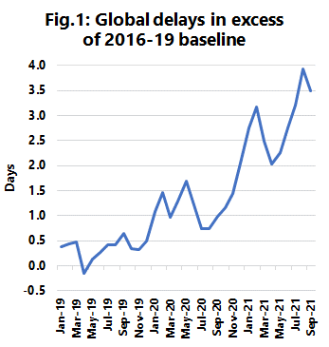
Figure 1 shows how these excess delays have developed over the January 2019 to September 2021 period. While there was an initial pandemic increase in delays in the first half of 2020, after a brief period of improvement in summer 2020, the delays then escalated significantly in late 2020 and early 2021.The problems continued to worsen as we get into summer and autumn 2021, with the peak of 3.93 days reached in August 2021.
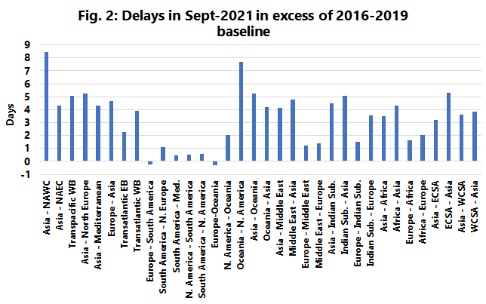
However, the more pertinent question is whether the global average is representative of all trade lanes. Figure 2 shows the vessel delays in September 2021 in excess of the 2016-2019 baseline, for the 34 trade lanes covered in the Global Liner Performance report. Here we see a very large spread indeed. Most trades show very large increases in delays, indicating that the congestion problems leading to delays are indeed prevalent globally and not isolated to just a few large key trades.
However, it can also be seen that a few individual trades are not impacted, and essentially have the same magnitude of delays as they had before the pandemic. These, relatively less impacted trade lanes, are mostly connected to South America, from both Europe and North America.
--- 000 --- END OF PRESS RELEASE --- 000 ---
All quotes can be attributed to: Alan Murphy, CEO, Sea-Intelligence.
For more information, please contact: ia@sea-intelligence.com, am@sea-intelligence.com

