919 blank sailings on Transpacific and Asia-Europe
Sea-Intelligence – Press Release (May 4th, 2021)
www.Sea-Intelligence.com

Since the start of the pandemic, Sea-Intelligence has been issuing a weekly detailed report of the blank sailings announced by the carriers called the Blank sailings tracker. In issue 512 of the Sunday Spotlight, we used this data to analyse the carriers’ blank sailings behaviour since week 4 of 2020. The outlook extends to week 28 in 2021.
At present, the carriers have made (and announced) 919 blank sailings on Transpacific and Asia-Europe throughout this period. In early 2020, there was a spike in blank sailings announcements, as the initial Coronavirus outbreak shut down China and then as it spread globally from March. This was followed by an additional two spikes in May and August, although the August spike is more related to the anticipated seasonality for Golden Week. At this point however, the pattern changed, there were no more sharp spikes but a steady weekly flow of announced blank sailings, which now appears to be on an upwards trend.
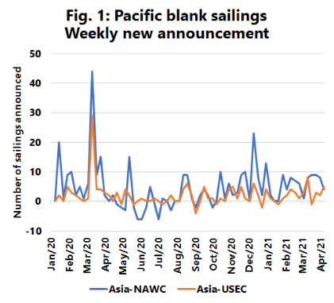
Figure 1 shows the breakdown of the weekly blank sailing announcements on the two component Transpacific trade lanes. There was a large increase in the number of blank sailings in March as the pandemic spread, after which, there was a slight decline on Asia-NAWC. During the summer, a peak of 178 was reached on Asia-NAWC, followed by a decline as sailings were essentially “un-blanked” due to the demand increase. A new pattern emerged in September 2020 with a steady level of blank sailings on both trades, resulting in a steady cumulative increase; a trend which is still in effect. We see a similar early spike in blank sailings in March on the two Asia-Europe trades, followed by a secondary spike in August 2020, no stabilising period in the late summer, and a similar ‘steady growth’ trend since September 2020, albeit with more week-to-week volatility.
As is well known in the market, there is currently a shortage of vessel capacity driven by a variety of factors, such as port congestion, vessel crew with Covid, vessels struck with engine malfunctions, etc., all of which implies that at least a part of the blank sailings presently are the result of operational necessity – there is simply no other choice when a vessel is unavailable, and no replacement can be had. What is also clear from our analysis is that the temporary closure of the Suez Canal in March 2021 has not given rise to any noticeable change in the carriers’ pattern of blank sailings announcement behaviour.
--- 000 --- END OF PRESS RELEASE --- 000 ---
All quotes can be attributed to: Alan Murphy, CEO, Sea-Intelligence.
For more information, please contact: ia@sea-intelligence.com, am@sea-intelligence.com

