Schedule reliability drops to record-low in December 2021
Sea-Intelligence – Press Release (Jan 27th, 2022)
www.Sea-Intelligence.com

Sea-Intelligence has published issue 125 of the Global Liner Performance (GLP) report, with schedule reliability figures up to and including December 2021. As the report itself is quite comprehensive and covers schedule reliability across 34 different trade lanes and 60+ carriers, this press release will only cover the global highlights from the full report.
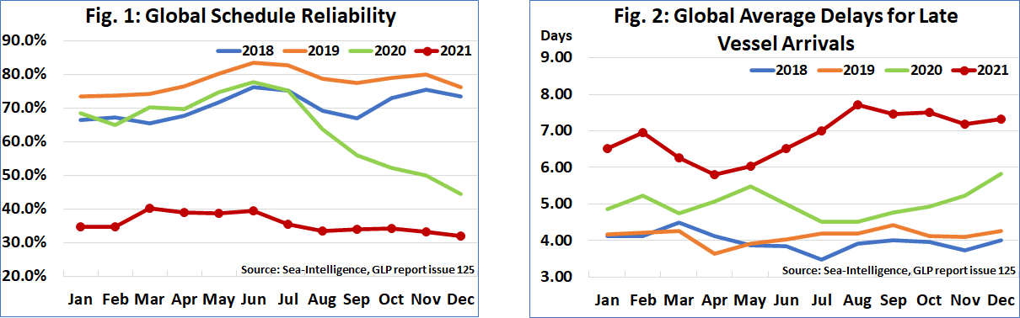
Schedule reliability dropped again, this time by -1.2 percentage points M/M to 32.0%; the lowest ever global schedule reliability since Sea-Intelligence started the measurement in 2011. On a Y/Y level, schedule reliability was -12.5 percentage points lower. Despite the low schedule reliability in 2021, there hasn’t been much fluctuation, with the global scores hovering between 32%-40% for the most part. The average delay for late vessel arrivals increased to 7.33 days; the fifth consecutive month with the delay figure above 7 days.
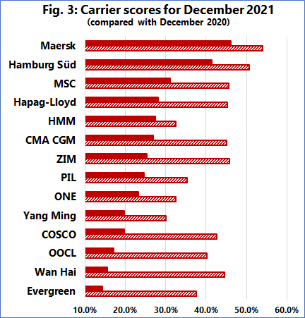
Maersk was once again the most reliable top-14 carrier in December 2021, with schedule reliability of 46.2%, followed by Hamburg Süd with 41.4%. Only MSC had schedule reliability between 30%-40%, with six carriers recording schedule reliability of 20%-30%. The remaining five carriers had schedule reliability of under 20%, with Evergreen recording the lowest December 2021 schedule reliability figure of 14.3%. Nine carriers recorded a M/M improvement in schedule reliability, while no carrier recorded a Y/Y improvement in schedule reliability, with all but four carriers recording double-digit Y/Y declines.
--- 000 --- END OF PRESS RELEASE --- 000 ---

All quotes can be attributed to: Alan Murphy, CEO, Sea-Intelligence.
For more information, please contact: ia@sea-intelligence.com, am@sea-intelligence.com

