Schedule reliability drops to record-low in January 2022
Sea-Intelligence – Press Release (Feb 28th, 2022)
www.Sea-Intelligence.com

Sea-Intelligence has published issue 126 of the Global Liner Performance (GLP) report, with schedule reliability figures up to and including January 2022. As the report itself is quite comprehensive and covers schedule reliability across 34 different trade lanes and 60+ carriers, this press release will only cover the global highlights from the full report.
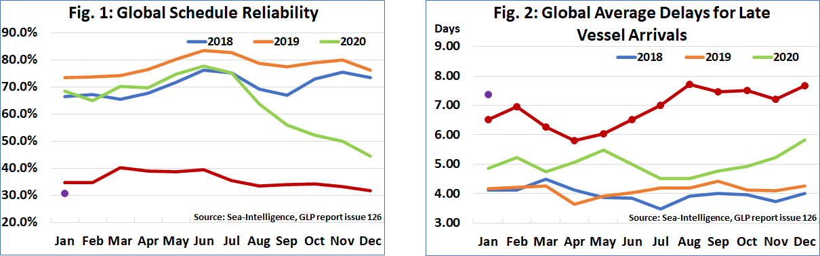
Schedule reliability dropped again, this time by -0.9 percentage points M/M to 30.9%; the lowest ever global schedule reliability since Sea-Intelligence started the measure in 2011. On a Y/Y level, schedule reliability was down -3.8 percentage points. Despite the low schedule reliability since January 2021, there hasn’t been much fluctuation, with the global scores largely between 30%-40%. The average delay for late vessel arrivals decreased slightly to 7.38 days, the sixth consecutive month with the delay figure above 7 days.
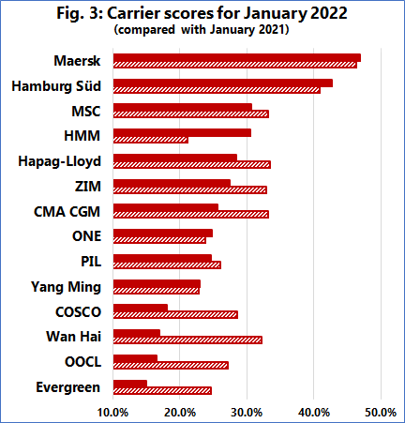
Maersk was once again the most reliable top-14 carrier in January 2022, with schedule reliability of 46.9%, followed by Hamburg Süd with 42.8%. MSC and HMM had schedule reliability between 30%-40%, with six carriers recording schedule reliability of 20%-30%. The remaining four carriers had schedule reliability of under 20%, with Evergreen recording the lowest January 2022 schedule reliability figure of 15.0%. Ten carriers recorded a M/M improvement in schedule reliability, while five carriers recorded a Y/Y improvement in schedule reliability, with only three carriers recording double-digit Y/Y declines.
--- 000 --- END OF PRESS RELEASE --- 000 ---

All quotes can be attributed to: Alan Murphy, CEO, Sea-Intelligence.
For more information, please contact: ia@sea-intelligence.com, am@sea-intelligence.com

