Schedule reliability continues on its upwards trend
Sea-Intelligence – Press Release (Dec 29th, 2022)
www.Sea-Intelligence.com

Sea-Intelligence has published issue 136 of the Global Liner Performance (GLP) report, with schedule reliability figures up to and including November 2022. As the report itself is quite comprehensive and covers schedule reliability across 34 different trade lanes and 60+ carriers, this press release will only cover the global highlights from the full report.
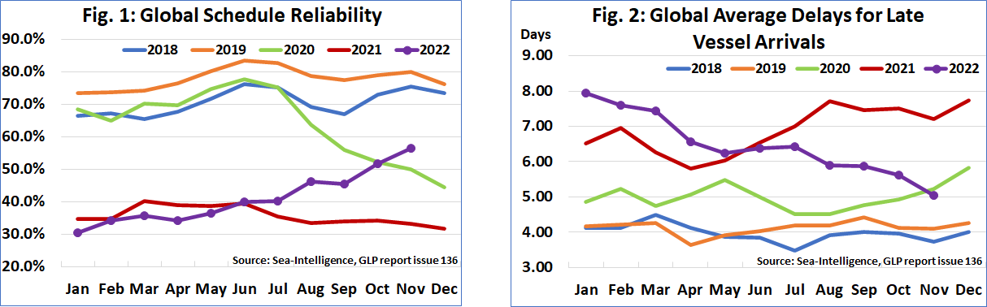
Global schedule reliability improved by 4.7 percentage points M/M in November 2022 and reached 56.6%. The average delay for LATE vessel arrivals has also been improving consistently since the start of the year. In November 2022, average delay improved once again, dropping by another -0.58 days M/M to 5.04 days. Both schedule reliability and average delay are now better than the 2020 level as well.
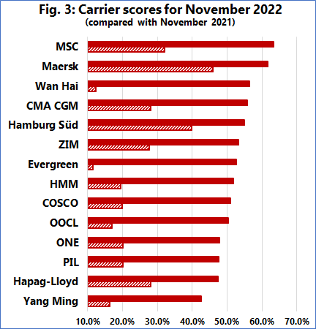
With schedule reliability of 63.4%, MSC was the most reliable carrier in November 2022, followed by Maersk with 61.7%. They were the only carriers above 60%. The next 8 carriers recorded schedule reliability of 50%-60%, while 4 carriers recorded schedule reliability of 40%-50%. Yang Ming recorded the lowest schedule reliability of 42.5%. Apart from Yang Ming, all of the top-14 carriers recorded a M/M improvement in schedule reliability, whereas all carriers recorded a double-digit Y/Y improvement in schedule reliability, with 12 carriers recording improvements of over 20 percentage points.
--- 000 --- END OF PRESS RELEASE --- 000 ---
All quotes can be attributed to: Alan Murphy, CEO, Sea-Intelligence.
For more information, please contact: ia@sea-intelligence.com, am@sea-intelligence.com

